DEMAND FORECASTING
- Project overview: This project analyses customer shopping behaviour from 76,000 Purchases across various project category. The goal is to uncover insights into Demand, sales, inventory, category to guid strategic business decisions.
- Dataset Summary:
- 76,000 rows
- 16 columns
- Key features: stores, products, sales, inventory, pricing, promotions, weather, seasonality, and demand.
- No missing data
- Exploratory Data Analysis using Python
We began with data preparation and cleaning in Python:
- Data Loading: Imported the dataset using pandas.
- Initial Exploration: Used df.info() to check structure and .describe() for summary statistics.
- df.info()
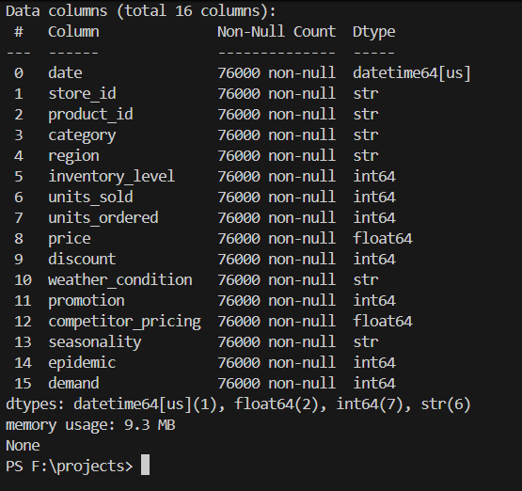
- df.describe()
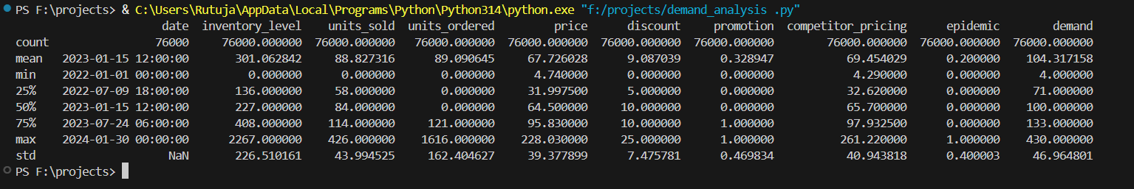
- Missing Data Handling: Checked for null values but there we no null values in the dataset
- Column Standardization: Renamed columns to snake case for better readability and documentation
- Feature Engineering: The Date column was of str type changed it to datetime type.
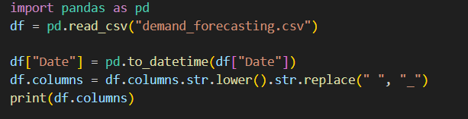

- Data Analysis using Python (Pandas)
We performed structured analysis in V.S.Code to answer key business questions:
- Total demand
- Average demand
- Minimum demand
- Maximum demand

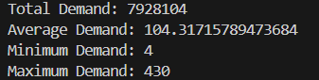
- Region wise demand Analysis

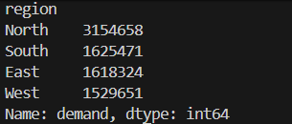
- Category wise demand analysis

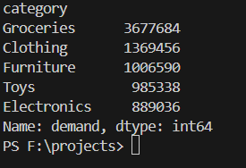

- Category wise units sold analysis

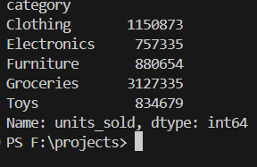
- Category wise prices analysis
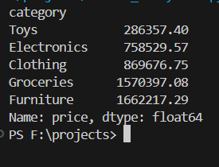
- Demand vs discount analysis
- 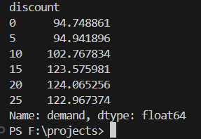
Business question: Do higher discounts lead to higher demand: yes

- Promotion wise demand analysis
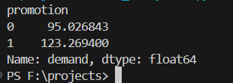
Business quest: Does running a promotion increase average demand?
Yes stakeholders should promote their business to increase the demand of business.
- Data Analysis using SQL (Business Transactions)
We performed structured analysis in MYSQL to answer key business questions:
We changed the datatype of the date column from str to date type
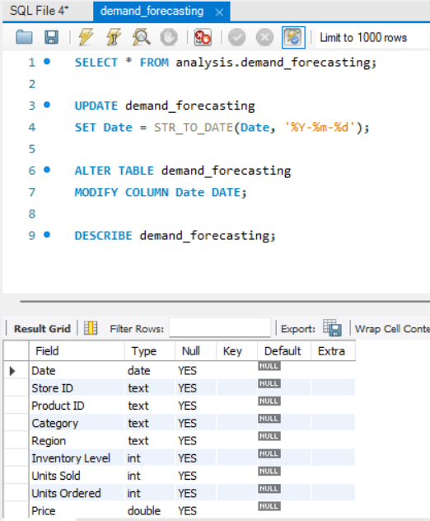

- Checked for total demand

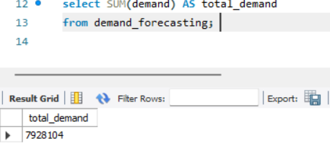

- To check total unit sold
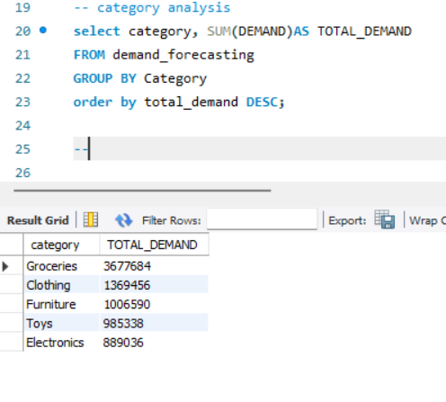
- To check Average price

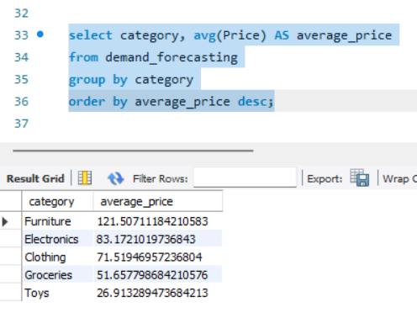
- To check region wise demand

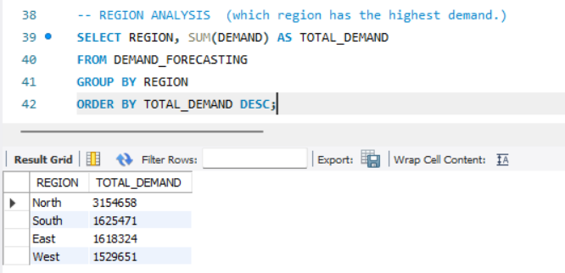

- Unit sold by region
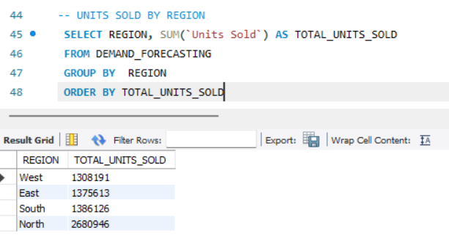
- Promotion

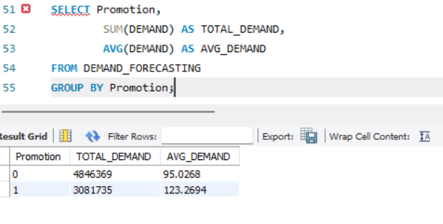
- Demand by seasonality
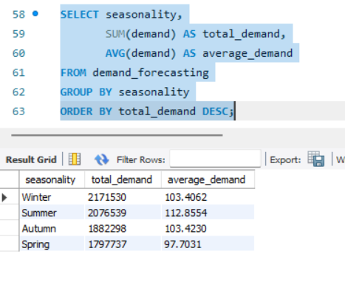
- Demands over years
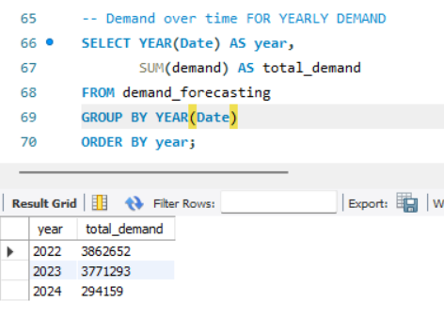

- DASHBOARDS:

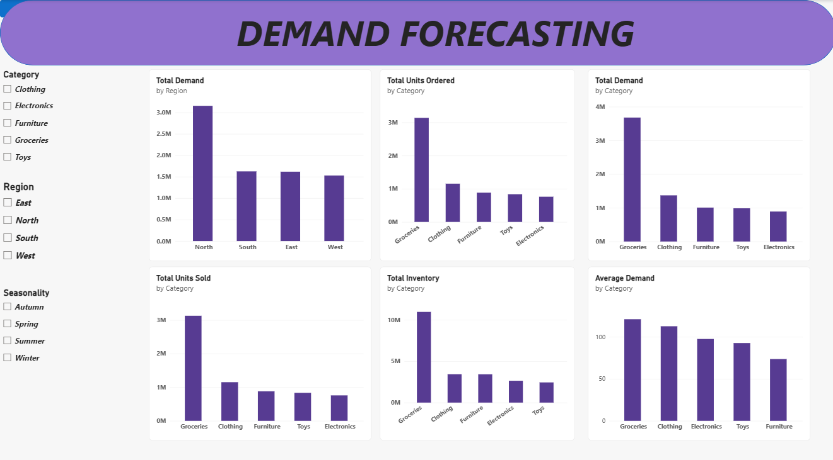

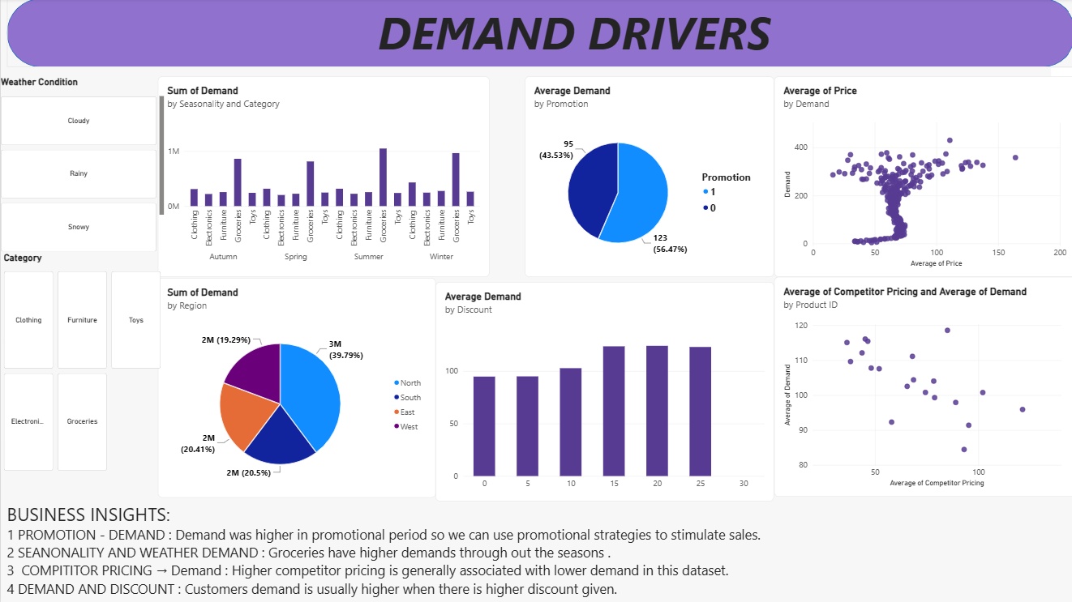

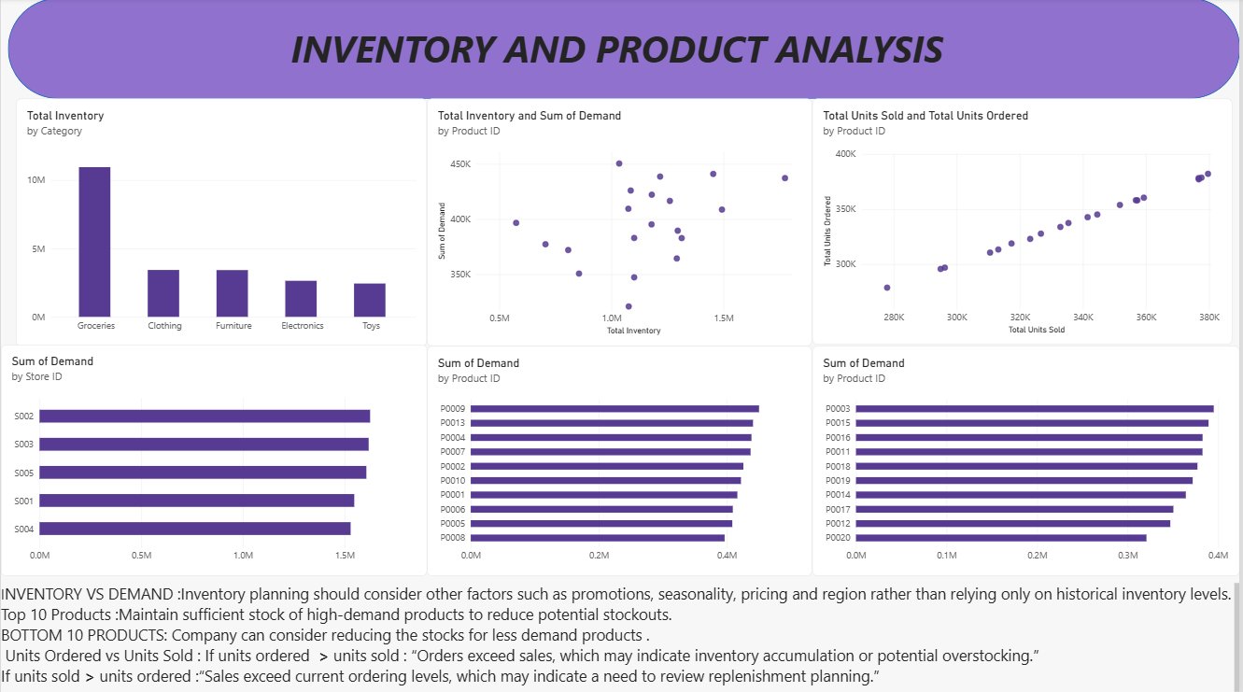

7.BUSINESS RECOMMENDATION:
1. PROMOTION: DEMAND WAS HIGHER IN PROMOTIONAL PERIOD SO WE CAN USE PROMOTIONAL STRATEGIES TO STIMULATE BUSINESS GROWTH.
2. DISCOUNT: CUSTOMER DEMADN IS USUALLY HIGHER WHEN THERE IS HIGHER DISCOUNT GIVEN SO WE CAN TRY TO GIVE MORE REASONABLE DISCOUNTS TO CUSTOMER
3. TARGETED MARKETING: FOCUS ON HIGH REVENUE GENERATING PRODUCTS. AND HIGHLIGHT TOP RATED PRODUCTS.

